Principal-Preparation Programs Get Major Makeover in Illinois
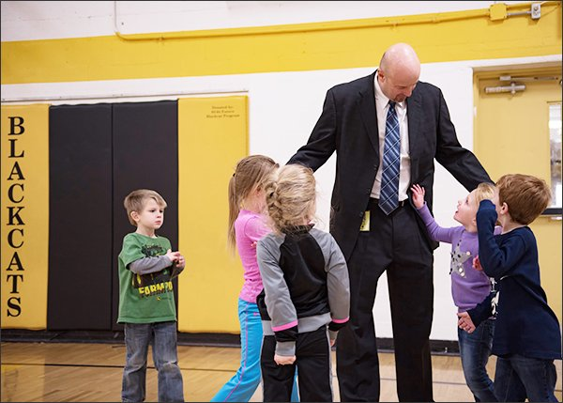
Goreville, Ill., Superintendent Steve Webb greets students at Goreville Elementary School. Webb says the state’s new requirements for principal training make it harder for rural districts like his to find qualified candidates.
—Jayson Holland for Education Week
The state's push to upgrade its cadre of school leaders shifts programs' emphasis to instructional leadership
By Corey Mitchell January 24, 2017
In a move meant to ensure that school principals are instructional leaders, Illinois became the first state in the nation to create a specific endorsement for the lead role across pre-K through secondary schools. The state's move in 2010 has since led colleges and school districts to revamp how they prepare prospective principals to serve as leaders whose chief responsibility is to help teachers get better at instruction.
While some universities in the state are touting the benefits of that overhaul—which is still a work-in-progress—researchers and school district administrators are analyzing the pros and cons of the changes and reserving judgment on how well it has worked.
Before the change, educators in Illinois who wanted to work as principals had to earn a general administrative license that would allow them to serve in schools' top jobs, but it also provided the necessary credential to work as athletic directors or deans charged with managing student discipline issues.
In a state that typically has between 450 and 500 principal vacancies to fill every year, tens of thousands of educators held the general administrative endorsement. But despite the number of potential principals, districts complained that they couldn't find qualified candidates. Researchers say many of the candidates sought out the credentials to earn pay increases, with no intention to ever lead schools.
Now, the state has preparation programs exclusively for aspiring principals. Admissions criteria are stringent. Candidates must complete yearlong internships and other requirements. And universities partner closely with school districts to prepare the kinds of principals they need.
A New Client
All of those changes have shrunk the candidate pool dramatically: 26 programs coach and counsel fewer than 700 principal-candidates each year.
"Our client is no longer the graduate student who wants to be a principal, our client is the public school child who needs a good principal," said Steve Tozer, an education professor at the University of Illinois at Chicago.
A growing body of research indicates that principals play a critical role in improving student performance and leading effective schools. Most work in the field shows that principals who can help teachers improve their classroom instruction provide much more value than those who focus primarily on serving as effective building managers.
"School districts and kids pay an immediate price for principals who aren't good at what they do," said Tozer, who directs the Urban Education Leadership program, which prepares principals.
Searching for Results
A 2016 report found that Illinois' revamped preparation requirements are showing promise for the attention they place on principal-candidates' knowledge and understanding of the needs of particular students: those still learning English, those with disabilities, and those who are prekindergarten students. The report, by the Illinois Education Research Council and the University of Chicago Consortium on School Research, says that is likely a result of the pre-kindergarten through 12th grade licensure that the state's preparation programs require.
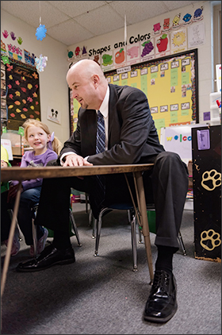
Kindergartner Abigail Payne smiles at Superintendent Steve Webb during his visit to Goreville Elementary School. Webb’s district is trying to adjust to Illinois’ more stringent requirements for principal training.
—Jayson Holland for Education Week
The report makes the case that principal training that zeroes in on specific student groups and specific grade levels could yield better results for students, but it may take years to ferret out that data, said Bradford White, a senior researcher at the Illinois Education Research Council who worked on the analysis. That's because it takes several years for most candidates to matriculate through the preparation programs, and many don't immediately land principals' jobs once they do. Some start off as assistant principals or return to classrooms and await administrative openings.
The struggle to find definitive answers is complicated because not all of the state's programs are tracking data on graduates and their outcomes.
"In theory, it sounds like we're doing all the right things but ... I'm not super comfortable saying everyone should be diving on board and doing this," White said. "It's probably a move in the right direction, but some of that remains to be seen."
Tozer and others at the University of Illinois at Chicago, which began redesigning how it prepares principals in collaboration with the Chicago school district well before the statewide makeover, point to signs of school improvement in that city as proof that well-designed programs do increase achievement and other measures of success. High schools led by principals who are alumni of the program have improved attendance and graduations at levels that exceed comparable district schools. The district-university partnership has spanned the tenures of six Chicago schools CEOs, an indicator that the principal-preparation goals, if developed carefully, can survive and possibly even thrive in spite of district-level leadership changes.
The University of Illinois-Chicago program mandates a full-year, full-time paid leadership residency and one-on-one leadership coaching for three years after graduates finish the program.
The rigor of the program—where much of the skills and knowledge are learned in a real-life school setting—is something districts and universities all need to move toward, Tozer said.
"Any teacher who wants a principal credential in the [United States] can get one. We put principals in charge of the lives of kids and teachers who have never actually led before because they've read about it in class," Tozer said. "That's the standard model in the U.S."
The Education Commission of the States—a Denver-based think tank that conducts research on state education policy—honored Illinois in 2014 for its work on principal preparation, and some districts around the nation have looked to follow the state's lead, but not everyone in the Prairie State is convinced the changes are a good fit.
Rural Struggles
While the new regulations may prove to be a boon for metropolitan areas with a glut of candidates, rural, underpopulated areas could struggle, said Steve Webb, the superintendent of the 560-student Goreville school system in the state's southern tip.
A board member and past president of the Association of Illinois Rural and Small Schools Association, Webb said small districts found it difficult to attract quality school leader candidates before the new requirements, which he worries have exacerbated the problem.
Districts that once had dozens of applicants for a single opening now draw fewer than 10 candidates. The stringent academic standards and new regulations have placed excessive restrictions on the principal pipeline, stripping decision-making power from local school boards and administrators and granting that authority to people who don't work in K-12 schools, Webb said.
"Why are we giving the universities and bureaucrats the power to choose our local principals?" asked Webb, an adjunct professor of educational administration at Southern Illinois University, Carbondale. "Shouldn't our local school boards have that power?"
There are concerns in other parts of Illinois that the state will fail to train enough principals in the coming years to fill openings, said Jason Leahy, the executive director of the Illinois Principals Association. That concern is amplified by the changing nature of the principal's job, which makes huge demands of those in the profession.
"School leader jobs are pretty untenable with everything they're being asked to do," Leahy said. "Teachers are seeing that and are choosing another path or staying put."
While the state boards of K-12 and higher education were overly concerned with producing too many candidates under the old system, the state should be aiming to train two to three times as many principals as it currently does, Leahy said. "(The state) overcorrected," he said, adding that "I wouldn't go back to where we were, either."
Long Haul
The work to overhaul the state's principal-preparation regulations was a decade-long process that began long before the state enacted the changes. But more important than the policy shift was a change in the approach to the work, Tozer said, especially when it comes to serving students in struggling schools.
"It might be the case that there is no more cost-effective measure for improving underserved schools than putting the right leadership in place," Tozer said.
But Leahy argues that the pre-kindergarten through 12th-grade certification, designed to make prospective principals more aware of the challenges students in their schools face, forces candidates to become "jacks-of-all-trades rather than what it takes to lead an organization."
The Illinois Research Council and University of Chicago Consortium on School Research found—through an analysis of course syllabi—that organizational leadership has not been de-emphasized in preparing the state's future principals for the demands of the job.
For principals to have an impact, "they need to learn how to change adult culture and climate in a school," Tozer said. "That's what's so terribly challenging because kids are actually easier to work with than adults are." That's why he and others argue that the required yearlong internship is crucial.
Related Blog
Webb, the rural superintendent, describes the intensive on-the-job training as a "more thoughtful, skills-based experience than what I had." But, he said, the requirement places smaller schools at a disadvantage. Forcing a teacher, often an exemplary one who is willing to work in small district, out of their classroom for a year to do an internship, leaves behind students who may desperately need them.
"That's a big sacrifice," Webb said.
But a sacrifice that could be well worth it, White counters.
"You train a stellar teacher and they make a huge impact on a classroom," he said, "you train a stellar principal and they can impact an entire school."
Coverage of leadership, expanded learning time, and arts learning is supported in part by a grant from the Wallace Foundation, at www.wallacefoundation.org. Education Week retains sole editorial control over the content of this coverage.
Vol. 36, Issue 19, Pages s16, s17, s18, s20
Published in Print: January 25, 2017, as Principal Prep Gets Makeover in Illinois

